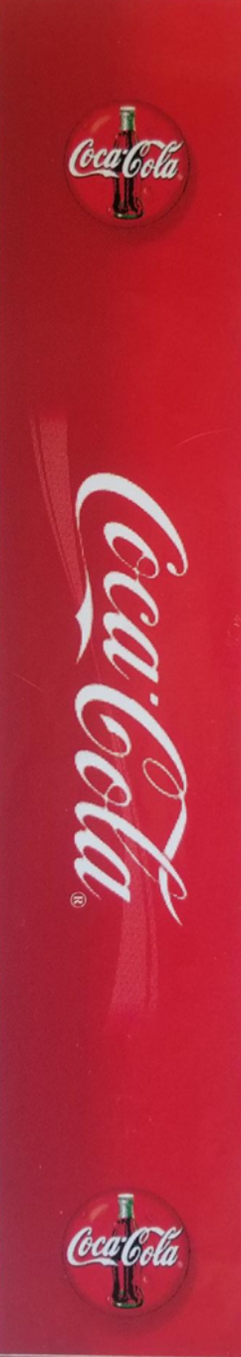

1” wide

This is the template for a custom golf label. It is 2” wide x 10 ¼” high. Golf shafts are mostly .600” or so wide, so the label will overlap slightly. Most label designs have text that is ¾” – 1” wide. This text should be centered. This allows the text to be seen without rotating the shaft. Here are a few different custom labels to help you with your custom design. You can design this easily in Microsoft Word, or any of the other more advanced programs.
When finished, please upload, select the grip(s) and make your payment.

SAMPLE LABEL DESIGNS

