NAME

#

NAME

HOCKEY LABEL TEMPLATE

4” WIDE X 8” HIGH

LOGOS on top and bottom are 1” wide

Names on side are 3/4” wide

# and number is ½”wide.

Center the # and number

½” spacing between the edges and the text boxes.

**½” ½” ½” ½”**

**LOGO**

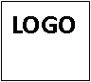

½”

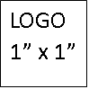

LOGO1” x 1”